When you define a report definition, the definition identifies the information required in a report, who receives the report, and what, if any, reminders will be sent out to ensure the timely delivery of a report. The reports are generated based on the rules you create in Managing Rules. As a simple example, when an adverse event is entered, and the adverse event data fulfills a rule, then a defined report can be generated. This topic describes how to enter, edit, disable, import, or export a report definition. To perform AdEERS reporting for a user-defined report, you can specify to send the report to the AdEERS URL on the Delivery Details page discussed in Entering Receivers of the Report.
Note: All required fields in caAERS have a red asterisk next to them. This means you must complete the field to save and continue to the next page. Based on the user role assigned to you by the caAERS Administrator and how the product was configured, you may not have access to all the fields and pages described in this topic.

Contents
[hide]
- 1 Entering Report Details
  - 1.1 Entering Receivers of the Report
  - 1.2 Specifying Mandatory Report Information
  - 1.3 Entering Reminders for the Report
  - 1.4 Reviewing the Report Definition
- 2 Editing a Report Definition
- 3 Disabling a Report Definition
- 4 Importing a Report Definition into caAERS
- 5 Exporting a caAERS Report Definition to an XML File

Entering Report Details
The Details page specifies information for the report, like the name and whether the report should be expedited.
To access report details
- Click the Rules tab.
- Select the Create Report Definition task.
To fill in report details
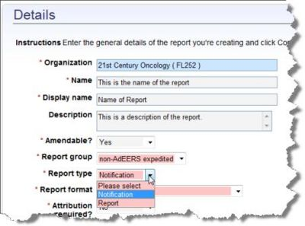
- For the Organization, enter the name or a portion of the name of the sponsor or site to which you want to generate a report. Select an organization from the list.
- Enter a Name for the report.
- Enter a simple, but descriptive Display Name for the report.
- Enter a Description if you want to add more information about the report.
- Specify whether the report will be Amendable. The default is Yes, which means you can amend the report even after it is submitted.
- Select a Report group that describes the category of the report. Some examples could be Local IRB, FDA Report, Local Institution, but you can use anything that applies to your organization.
  - To create a new report group, select Create New. The Create New Report Type window opens.
    - Specify a Code that will represent the new report group.
    - Specify a Name for the report group.
    - Provide a Description of the report group.
- Select a Report type to indicate whether to notify the recipients by sending the report or just informing them that the report was generated.
- Select a Report format to specify the output format of an expedited report. If you need to send the report to an email address or a role, the file format must be PDF. To send it to a URL, the report must be an XML file. Also, when you create the report, the fields listed on the Mandatory Fields page will vary based on the report format you select here.
  - caAERS XML generates an XML file of caAERS data.
  - AdEERS PDF is the Adverse Event Expedited Reported System.
  - MedWatch PDF is the FDA Safety Information and Adverse Event Reporting System form.
  - CIOMS Form is the Council for International Organizations of Medical Sciences form which for standardized international reporting of individual cases of serious, unexpected adverse drug reactions.
  - CIOMS SAE Form is the Council for International Organizations of Medical Sciences Serious Adverse Event form.
  - DCP SAE Form is the Division of Cancer Prevention Serious Adverse Event form.
- Specify whether this report is Attribution required. For each adverse event added, it is required that an attribution be associated with the adverse event. The attribution specifies the possible cause of the adverse event.
- Select a Time unit to specify the measurement of time before the report is due.
- Enter a Time value (for due date) to indicate when the report is due. This value is associated with the select Time unit. For example, if you choose Days for Time unit and 5 for the Time value, the report is due 5 days after a documented adverse event.
- Specify whether a Physician Signoff is required before submitting an expedited report.
- Select a Parent report (if any) for this current report. This sub-report will not be generated unless the parent report is generated.
- Specify whether the report is Workflow enabled? This is for Suite users only and specifies that it will show up in the Routing and Review option to track the reports.
- Specify whether to Enable the report for use at this time.
- Click Continue to go to the next step.
Warning: If you navigate from this page to a different area of caAERS without completing the entire report definition process, all information will be lost, even if you have clicked Continue.

Entering Receivers of the Report
The Delivery Details page (see Entering Report Details and follow the procedure to access this page) enables you to setup recipients for this report. The report can be sent to an email address, a role, or a URL. Reports sent to email addresses and roles are sent as PDF files while reports sent to URLs go through as XML files.
Note: To ensure proper communication with AdEERS, specify to send the report to the AdEERS URL.
- Sending a report to an email address, sends the report to a specific email address. Note that each time ANY study associated with this report definition expedites the report, and the report will be emailed to the email address.
- Send a report to a role, sends the report to the person in the specified role at the selected organization for the specified study. The report will still be sent to an e-mail address listed for the role in the study, but if the person(s) listed for the role changes, the report will automatically be sent to the new person in the role.
- Send a report to a URL electronically submits the report to the URL. If you want to perform AdEERS reporting for a user-defined report, specify the AdEERS URL. If you do not know the AdEERS URL, contact AdEERS support.
To set up recipients for the report
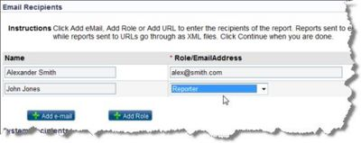
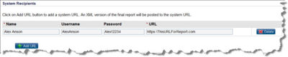
- To add a recipient's email, click Add eMail.
  - Enter the Name of the recipient.
  - Enter the Email Address of the recipient.
- To add a recipient role instead of an individual's name, click Add Role.
  - In the Name field enter information to identify the role.
  - Select the Role that will receive the report. For more information about roles, see Roles in caAERS. For information about investigators, see Adding Investigators
- To submit the report to a URL or web service, click Add URL.
  - Enter the Name of the URL. This can be the recipient’s name or another way to identify the URL.
  - If the site has security, enter a Username and Password.
  - Enter the complete URL.
- To delete a recipient, click Delete to the right of the recipient.
- To save the information and continue to the Mandatory Fields page, click Save and Continue.

Specifying Mandatory Report Information
The Mandatory Fields page (see Entering Report Details and follow the procedure to access this page) lists all of the information that you can require the user to include in an expedited report. The information is categorized and will be included as different sections in the report. When a user reports adverse events (see Reporting Adverse Events in caAERS), the user will be prompted to fill in this information. If you specify that a field is "Mandatory" the user cannot continue to the next page until the required fields are completed.
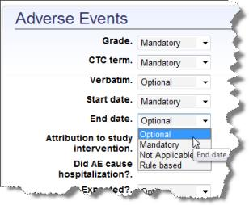
The information on this page is categorized. For more information on these items follow the category link for descriptions. For each item listed, select Optional, Mandatory or Not Applicable. Rule Based means that the rules will specify whether the field must be filled in.
- For entering Adverse Events see Adding Adverse Events.
- For specifying Course see Specifying Course of Treatment.
- For adding Agent see Adding Agents.
- For Reporter see Adding the Person Who Reported the Adverse Event.
- For Describing Adverse Event see Describing the Adverse Event.
- For adding Subject Details see Adding Subject Details.
- For entering Other Contributing Causes for the adverse event see Entering Other Causes of the Adverse Event.
- For adding Study Interventions see Radiation and Surgery.
- For adding Medical Devices see Medical Devices.
- For entering Labs see Entering Adverse Event Lab Information and search for the name of the item.

Entering Reminders for the Report
You can set up the Notifications page (see Entering Report Details and follow the procedure to access this page) to send email reminders to users so that they send reports out on time. Multiple reminders can be created for the same report, reminding people that the report is almost due or informing them the report is past due. Notifications can be emailed to email addresses, roles, or a combination of the two. You can also enter variables in the email message, for example, a study or patient ID can be listed in the subject line.
To add a notification
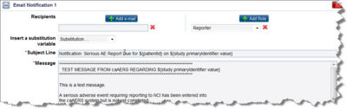
- To specify the timing of the notification, your Time Scale may be for Hours or for Days. This is specified on the Report Definition Details page). For example, if your time scale is in days, and your report is due on Day 5, you could select 2 to send a reminder three days before the report is due.
- You can send a notification to an email address or a role.
  - To send a notification to an email address, click Add eMail and enter an email address.
  - To send a notification to a role, click Add Role and select a role from the list. If you select role, the reminder will always be sent to the person assigned that role. If a person leaves a position, the new person will receive the reminder.
  - You can add multiple email and role recipients.
  - To delete a recipient, click the x to the right of the recipient.
- The notification is entered as an email:
  - Enter a Subject Line for the notification.
  - Type the body of the message in the Message field.
  - You can add variables to the notification so that, for example, the title of the study is pulled from caAERS and added to the message. To add a variable, place your cursor where you want the variable to appear, then select a variable from Insert a substitution variable:
    - Patient ID is added as ${patientId}
    - URL to Report is added as ${reportURL}
    - Study Short Title is added as {study.shortTitle}
    - Study Primary Identifier is added as ${study.primaryIdentifier.value}
- To add additional notifications for the same time period, for example, you could have two different notifications being sent three days before the report is due, click Add Notification and a second Email notification opens.
  - To minimize a notification click the minus sign next to the notification title.
- To add notifications for a different time period, for example, the day after the report was due, select a new number from Time Scale box. The notifications previously created are saved and the page shows only notifications setup for the new time period.
- To delete a notification, click x on the far right of the Email Notification # section.
- To save the changes, click Save.
  - To save and return to the previous page, click Save and Back.
- To save and continue to the Review page, click Save and Continue.

Reviewing the Report Definition
The Review page (see Entering Report Details and follow the procedure to access this page) allows you to review the Report Definition that you created. If the information is correct, click Save to continue to the Manage/Import Report Definitions. If you want to make changes, click Back to return to previous sections and made your changes.
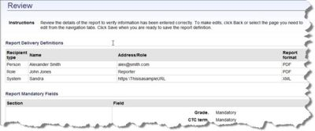

Editing a Report Definition
The Manage/Import Report Definition page lists all the user-defined reports in caAERS split into Manage active report definitions and Manage inactive report definitions. At the bottom of the page is the option to Import definitions from an XML file.
Note: You can sort rule sets by any column with a triangle next to the name. Click the column name to sort the list in ascending order based on the column contents. Click the column name again to sort by descending order.
To edit a report definition
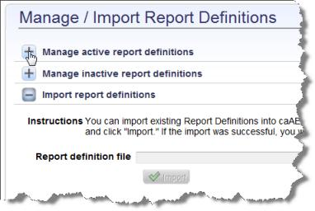
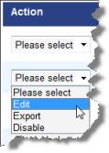
- Click the Rules tab.
- Click the Manage Report Definitions task menu. The Manage/Import Report Definitions page opens listing all of the reports in caAERS.
- For each report there is the following information:
  - Rule Level is one of four levels (Sponsor, Sponsor defined by a study, Institution, Institution defined by a study). The defined by a study levels are rules that apply to studies, not just anothing associated with the organization.
  - Report Name
  - Report Description
  - Organization indicates the organization to which this report applies.
  - Final Report Due is the amount of time after an adverse event is entered in caAERS that the report is due.
- To edit a report definition, select Edit in the Action column. Are you sure you want to take the action? Click OK for yes and No to return. See Entering Report Details.
- You can also perform other report definition tasks:
  - To disable a report, see Disabling a Report Definition.
  - To import a report definition into caAERS, see Importing a Report Definition.
  - To export a report definition to an XML file, see Exporting a Report Definition to an XML File.
  - To add a new report, click New Report Definition and the Details page opens. See Entering Report Details.

Disabling a Report Definition
The Manage/Import Report Definition page enables you to disable a report definition. When you disable a report, the report remains on the list but will not be generated.
Note: You can sort rule sets by any column with a triangle next to the name. Click the column name to sort the list in ascending order based on the column contents. Click the column name again to sort by descending order.
To disable a report definition
Image:URptDisable.jpg
- Click the Rules tab.
- Click the Manage Report Definitions task menu. The Manage/Import Report Definitions page opens listing all of the reports in caAERS.
- For each report there is the following information:
  - Rule Level is one of four levels (Sponsor, Sponsor defined by a study, Institution, Institution defined by a study). The defined by a study levels are rules that apply to studies, not just anothing associated with the organization.
  - Report Name
  - Report Description
  - Organization indicates the organization to which this report applies.
  - Final Report Due is the amount of time after an adverse event is entered in caAERS that the report is due.
- To disable a report, find the report, click the Action column box and select Disable. To enable the report, select Enable from the Action column.
- You can also perform other report definition tasks:
  - To edit a report definition, select Edit in the Action column. Are you sure you want to take the action? Click OK for yes and No to return. See Entering Report Details.
  - To import a report definition into caAERS, see Importing a Report Definition.
  - To export a report definition to an XML file, see Exporting a Report Definition to an XML File.
  - To add a new report, click New Report Definition and the Details page opens. See Entering Report Details.

Importing a Report Definition into caAERS
The Manage/Import Report Definition page enables you to import an existing report definition into caAERS. This is easier and faster than adding a report definition to caAERS manually. This may be useful if you are setting up an additional caAERS machine or a test machine. You can export the report definitions from caAERS (see Exporting a Report Definition) and then import them into caAERS.
Import Advise We advise to import the 24hr notification(s) first, along with any other reports that are parent reports. If you import a child report prior to a parent report, you will receive message on the screen from caAERS and you will need to re-import the child report definition after you import the parent report definition. A child report is generated only when the parent report is generated. If the report already exists in your caAERS system, the report definition will be updated.
Note: You can sort reports by any column with a triangle next to the name. Click the column name to sort the list in ascending order based on the column contents. Click the column name again to sort by descending order.
To import a report definition
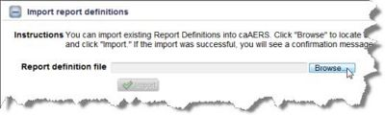
- Click the Rules tab
- Click the Manage/Import Report Definitions step task. The Manage/Import Report Definitions page opens.
- Go to the bottom of the page to the Import Report Definitions section.
- Click Import.
- If the import was successful, you will receive the message “Report definition imported successfully”. If it was not successful, you will receive a message telling you to contact the caAERS administrator.
- Once you import the report definitions, you can perform other tasks:
  - To edit a report definition, select Edit from the Action column. The message Are you sure you want to take the action? appears. Click OK for yes, or Cancel to return. The Details page opens. See Entering Report Details.
  - To disable a report, see Disabling a Report Definition.
  - To export the report definition to an XML file for import into another application, select Export and see Exporting a Report Definition to an XML File.
  - To add a report definition, click New Report Definition and the Details page opens. See Entering Report Details.

Exporting a caAERS Report Definition to an XML File
The Manage/Import Report Definitions page enables you to export a report definition from caAERS to an XML file. This is useful if you are adding caAERS to another machine or creating a test machine. You can export the report definition from one version of caAERS and import into the other (see Importing a Report Definition into caAERS).
Note: You can sort reports by any column with a triangle next to the name. Click the column name to sort the list in ascending order based on the column contents. Click the column name again to sort by descending order.
To export a report definition to an XML file
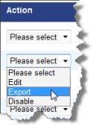
- Click the Rules tab
- Click the Manage Report Definitions step task. The Manage/Import page opens.
- There is a list of all the reports defined in caAERS. Find the report that you want to export.
- Select Export from the Action column. The message Are you sure you want to perform this action-Export? displays.
- Click OK to export the report or No to return to the list.
- Follow the prompts to Save the file to your computer or Open the file.
- Once you export the report, you can also perform other actions:
  - To disable a report, see Disabling a Report Definition.
  - To edit an existing report definition, select Edit from the Action column. The message Are you sure you want to take the action? appears. Click OK for yes, or Cancel to return. The Details page opens. See Entering Report Details.
  - To import existing report definition into caAERS, see Importing a Report Definition into caAERS.
  - To add a new report definition, click New Report Definition and the Details page opens. See Entering Report Details.

